CMPG322
Exercise 5.2 – PERT/Cost
- The General Foundry air pollution project discussed in the chapter has progressed over the past several weeks, and it is now the end of week 8. Lester Harky would like to know the value of the work completed, the amount of any cost overruns or underruns for the project, and the extent to which the project is ahead of or behind schedule by developing a table like Table 11.8. The revised cost figures are shown in the following table:
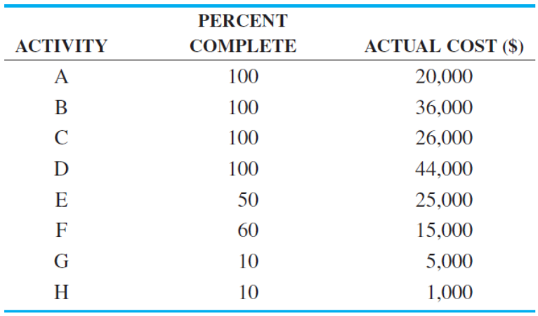

- Bowman Builders manufactures steel storage sheds for commercial use. Joe Bowman, president of Bowman Builders, is contemplating producing sheds for home use. The activities necessary to build an experimental model and related data are given in the following table:
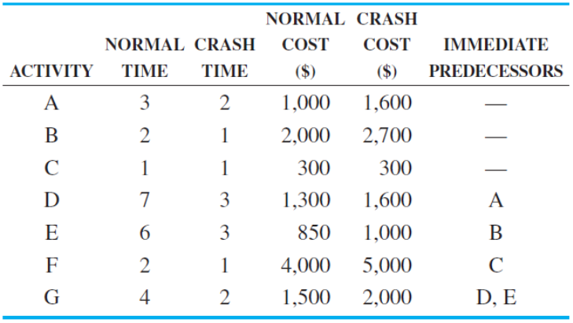
- What is the project completion date?
- Create an early start and late start time budget table for this project.

- The following costs have been estimated for the activities in a project:
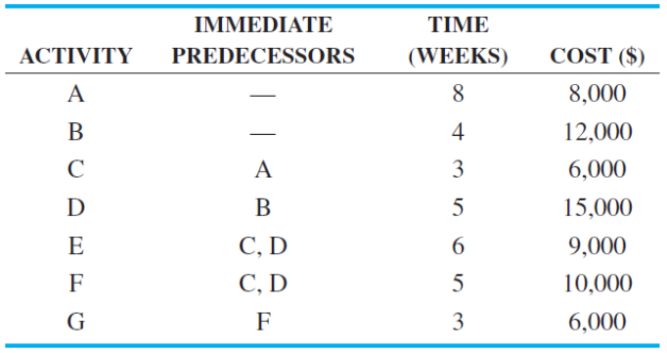
- Develop a cost schedule based on earliest start times.
- Develop a cost schedule based on latest start times.

